**IMPERIAL COLLEGE LONDON**

**BSc and MSci DEGREES – JANUARY 2014, for Internal Students of the Imperial College of Science, Technology and Medicine**

**This paper is also taken for the relevant examination for the Associateship**

**ADVANCED CHEMISTRY THEORY IIA**

**Inorganic Chemistry**

**Thursday 16th January 2014, 14:00-15:30**

**PLEASE NOTE THAT IT IS DEPARTMENTAL POLICY THAT THESE EXAM QUESTIONS MAY REQUIRE UNDERSTANDING OF ANY PRIOR CORE COURSE.**

**USE A SEPARATE ANSWER BOOK FOR EACH QUESTION. WRITE YOUR CANDIDATE NUMBER ON EACH ANSWER BOOK.**

**Year 2/0114 Turn Over**

**2I1 – Molecular Orbitals in Inorganic Chemistry**

Answer part a) and **EITHER** part b) **OR** part c) of this question.

1. Answer **BOTH** parts of this question.
2. **Construct** and **annotate** a valence MO diagram for LiH and HF, **include** all valence orbitals and the effects of mixing where appropriate. The Pauling electronegativity of H is 2.20, F is 3.98 and Li is 0.98.

(8 marks)

1. **Contrast** the HOMOs of LiH and HF, and **explain** the origin of any differences.

(5 marks)

1. A fragment E3 belongs to the D3h point group and consists of three atoms arranged in an equilateral triangle (*z* axis perpendicular to the plane of the page), shown below. The reducible representation (**A**) for the basis set **A** consisting of three pAOs is given below.

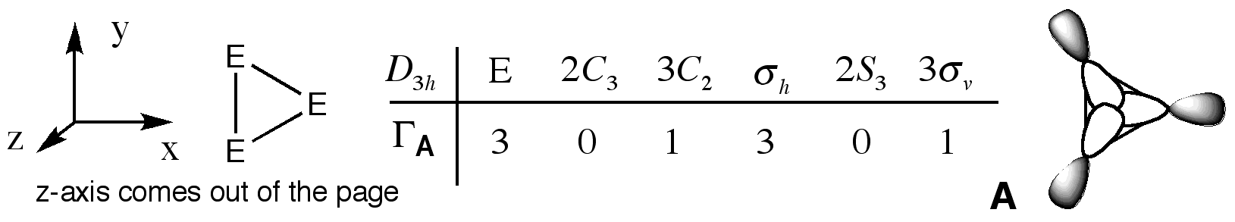

1. Determine the contributing irreducible representations using appropriate short cuts. **Show your working**.

(4 marks)

1. Use the projection operator to determine ONE wavefunction for the degenerate irreducible representation. **Show your working**. Draw the molecular orbital.

(8 marks)

1. The cation [Rh(NH3)4Cl2]+ belongs to the D4h point group.

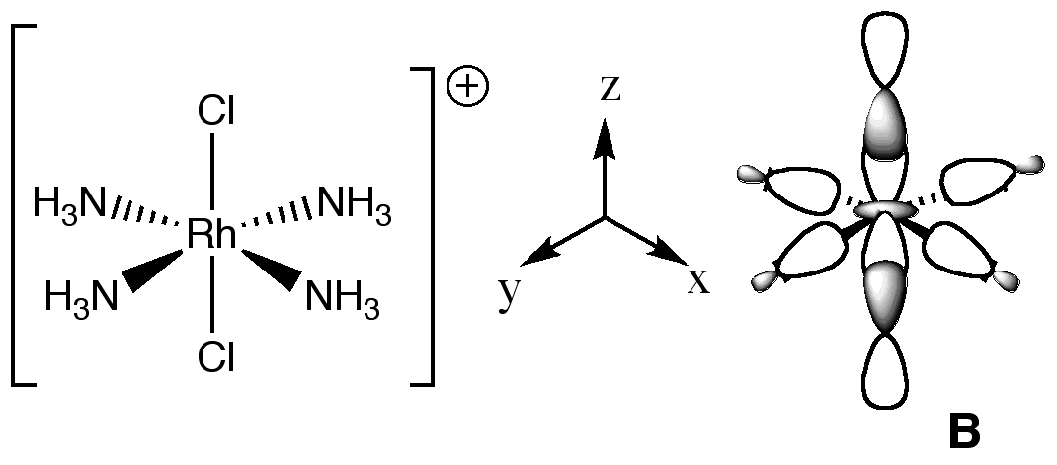

1. **Annotate** a diagram of MO **B**, **identify** and **explain** the features that are important in evaluating the overall bonding or antibonding character of this MO.

(5 marks)

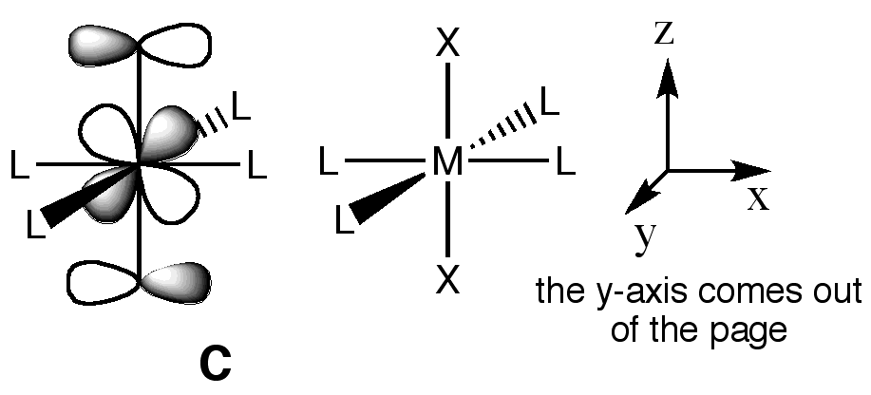

1. Draw a diagram **illustrating** the S41 operation on MO **C**.

(3 marks)

1. If you had to build a MO diagram for the cation [Rh(NH3)4Cl2]+, **describe** the best fragments to use and **explain** why.

(4 marks)

**2IS.1 – NMR and EPR Spectroscopy**

Answer part a) **AND** b),and **EITHER** part c) **OR** d) of this question.

1. Calculate the relative amounts of the three possible isotopic combinations of 77Se in the phosphine selenide (**I**) shown below. Use this information to sketch the proton decoupled 77Se NMR spectrum of (**I**), and label using the nJX-Y notation.

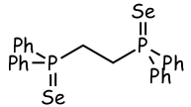

(**I**)

Assume that coupling of up to 4J can be observed. Also, assume that 31P is 100% abundant (I = ½), 77Se is 7.6% abundant (I = ½), and that no other nuclei present affect the spectrum.

(13 marks)

1. Sketch the proton coupled 13C NMR spectrum of the proton impurity, CD2HI, observed in samples of deuterated methyliodide, CD3I. Label any coupling present using the nJX-Y notation. Assume that only 1J coupling is observed.

Assume that 1H is 100% abundant (I = ½), 13C is 1% abundant (I = ½), 2D is 100% abundant (I = 1). γ for 1H is 26.7, for 2D it is 4.1 (107 rad T-1 s-1). No other nuclei present show significant NMR activity

(6 marks)

1. Lithium has two quadrupolar nuclei with the properties listed below. Which nucleus would be easier to observe by NMR spectroscopy? When might it also be useful to record spectra from the less readily observed nucleus? Give reasons for your answers.

Isotope Spin Natural Abundance Gyromagnetic ratio Linewidth factor

(I) (%)  (107 rad T-1s-1) 1056*l* (m4)

**____________________________________________________________________________________________**

6Li 1 7.4 3.93 3.2 x 10-6

7Li 3/2 92.6 10.40 2.1 x 10-3

(6 marks)

QUESTION CONTINUED OVERLEAF

1. Sketch and label the EPR spectrum for each of the two following radical fragments:
2. RH(C**·**)–CH2R
3. R2HC–(C**·**)H2

In each case, comment on the relative magnitudes of any coupling present and the relative intensities of the signals.

Assume that 1H is100% abundant (I = ½), and that no other nuclei or R groups present show significant epr coupling.

(6 marks)